# Mockito exercises

**Exercise 1: Mocking and Stubbing**

**pom.xml:**

<?xml version="1.0" encoding="UTF-8"?>  
<project xmlns="http://maven.apache.org/POM/4.0.0"  
 xmlns:xsi="http://www.w3.org/2001/XMLSchema-instance"  
 xsi:schemaLocation="http://maven.apache.org/POM/4.0.0 http://maven.apache.org/xsd/maven-4.0.0.xsd">  
 <modelVersion>4.0.0</modelVersion>  
  
 <groupId>org.example</groupId>  
 <artifactId>MockitoExample</artifactId>  
 <version>1.0-SNAPSHOT</version>  
  
 <properties>  
 <maven.compiler.source>17</maven.compiler.source>  
 <maven.compiler.target>17</maven.compiler.target>  
 <project.build.sourceEncoding>UTF-8</project.build.sourceEncoding>  
 </properties>  
  
 <dependencies>  
 <!-- JUnit 5 -->  
 <dependency>  
 <groupId>org.junit.jupiter</groupId>  
 <artifactId>junit-jupiter</artifactId>  
 <version>RELEASE</version>  
 <scope>test</scope>  
 </dependency>  
  
 <dependency>  
 <groupId>org.mockito</groupId>  
 <artifactId>mockito-core</artifactId>  
 <version>RELEASE</version>  
 <scope>test</scope>  
 </dependency>  
 </dependencies>  
  
</project>

**ExternalApi.java:**

package org.example;  
  
public interface ExternalApi {  
 String getData();  
}

**MyService.java:**

package org.example;  
  
public class MyService {  
 private ExternalApi api;  
  
 public MyService(ExternalApi api) {  
 this.api = api;  
 }  
  
 public String fetchData() {  
 return api.getData();  
 }  
}

**MyServiceTest.java**

package org.example;  
import static org.mockito.Mockito.*;  
import org.junit.jupiter.api.Test;  
import static org.junit.jupiter.api.Assertions.*;  
import org.mockito.Mockito;  
  
public class MyServiceTest {  
  
 @Test  
 public void testExternalApi() {  
 ExternalApi mockApi = Mockito.*mock*(ExternalApi.class);  
 *when*(mockApi.getData()).thenReturn("Mock Data");  
  
 MyService service = new MyService(mockApi);  
 String result = service.fetchData();  
  
 *assertEquals*("Mock Data", result);  
 }  
}

**OUTPUT:**

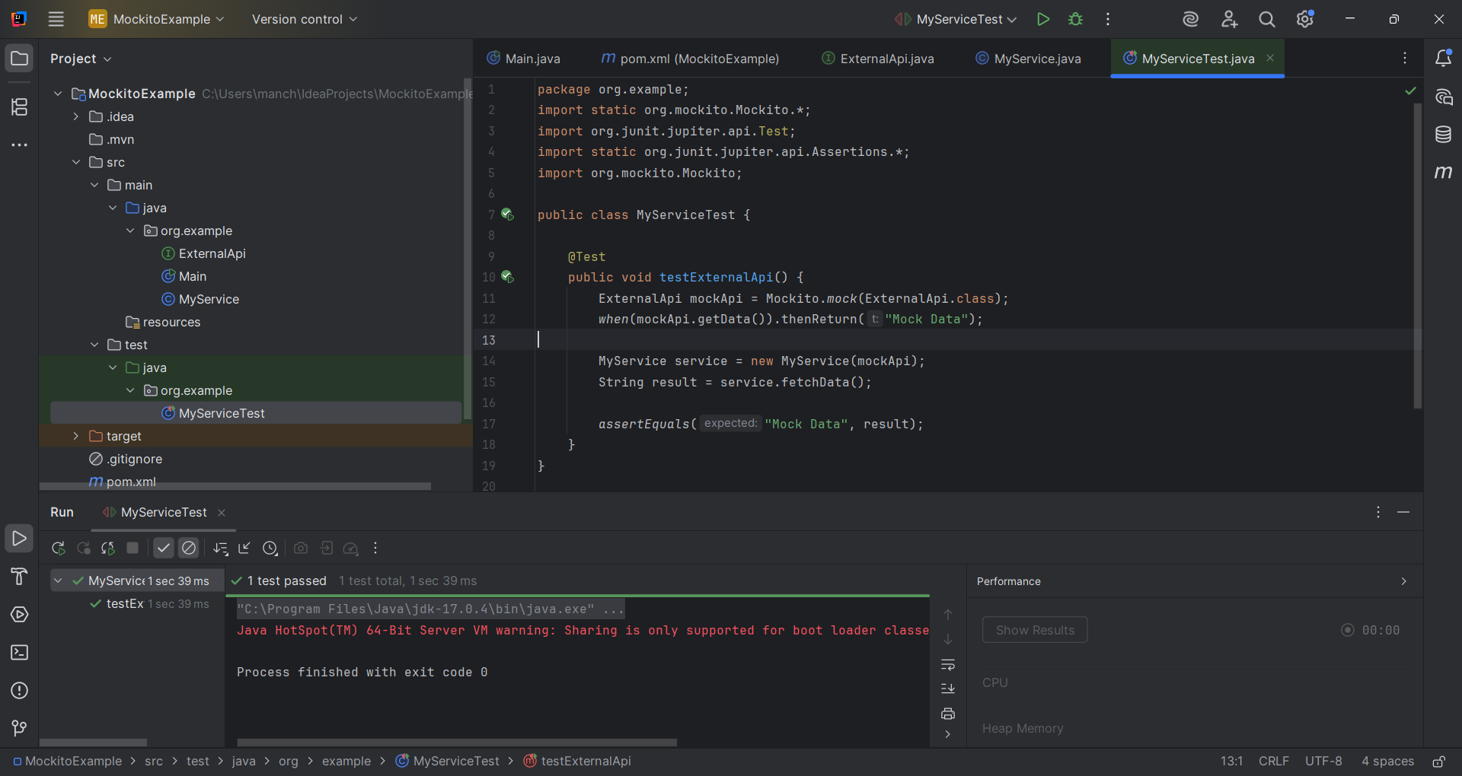

**Exercise 2: Verifying Interactions**

**pom.xml:**

<?xml version="1.0" encoding="UTF-8"?>  
<project xmlns="http://maven.apache.org/POM/4.0.0"  
 xmlns:xsi="http://www.w3.org/2001/XMLSchema-instance"  
 xsi:schemaLocation="http://maven.apache.org/POM/4.0.0 http://maven.apache.org/xsd/maven-4.0.0.xsd">  
 <modelVersion>4.0.0</modelVersion>  
  
 <groupId>org.example</groupId>  
 <artifactId>MockitoExample</artifactId>  
 <version>1.0-SNAPSHOT</version>  
  
 <properties>  
 <maven.compiler.source>17</maven.compiler.source>  
 <maven.compiler.target>17</maven.compiler.target>  
 <project.build.sourceEncoding>UTF-8</project.build.sourceEncoding>  
 </properties>  
  
 <dependencies>  
 <!-- JUnit 5 -->  
 <dependency>  
 <groupId>org.junit.jupiter</groupId>  
 <artifactId>junit-jupiter</artifactId>  
 <version>RELEASE</version>  
 <scope>test</scope>  
 </dependency>  
  
 <dependency>  
 <groupId>org.mockito</groupId>  
 <artifactId>mockito-core</artifactId>  
 <version>RELEASE</version>  
 <scope>test</scope>  
 </dependency>  
 </dependencies>  
  
</project>

**ExternalApi.java:**

package org.example;  
  
public interface ExternalApi {  
 String getData();  
}

**MyService.java:**

package org.example;  
  
public class MyService {  
 private ExternalApi api;  
  
 public MyService(ExternalApi api) {  
 this.api = api;  
 }  
  
 public String fetchData() {  
 return api.getData();  
 }  
}

**MyServiceTest.java:**

package org.example;  
import static org.mockito.Mockito.*;  
import org.junit.jupiter.api.Test;  
import org.mockito.Mockito;  
  
public class MyServiceTest {  
  
 @Test  
 public void testVerifyInteraction() {  
 ExternalApi mockApi = Mockito.*mock*(ExternalApi.class);  
 MyService service = new MyService(mockApi);  
 service.fetchData();  
 *verify*(mockApi).getData();  
 }  
}

**OUTPUT:**

